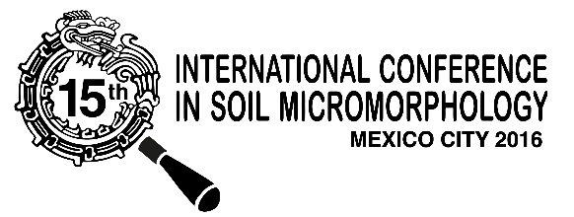

REGISTRATION FORM:

I intend to participate in the International “15th International Conference on Soil Micromorphology” 15ICSM in Mexico City, November 27 - December 5, 2016.

Name:

Institution: | Studient: | Investigator:
Postal Address:

Country:

Phone: | e-mail:
Fax: | Alternative e-mail:

I intend to submit a paper entitled:
Oral: | Poster:
Title work:

I intend to participate in Conference tours

Pre-Conference | Post-Conference

Date: | Signature:

Please fill and send this registration form to Héctor Cabadas: icsm@geologia.unam.mx

